Given the root of a binary tree, return *the sum of values of its deepest leaves*.

**Example 1:**

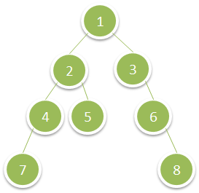

Input: root = [1,2,3,4,5,null,6,7,null,null,null,null,8]  
Output: 15

**Example 2:**

Input: root = [6,7,8,2,7,1,3,9,null,1,4,null,null,null,5]  
Output: 19

**Constraints:**

* The number of nodes in the tree is in the range [1, 104].
* 1 <= Node.val <= 100